Mid Sweden University
The Department of Information Technology and Media (ITM)
Author: Error: Reference source not found
E-mail address: fengjiao0313@gmail.com
Study programme: webprogrammering, 7.5hp
Examiner: Mikael Hasselmalm, Mikael.hasselmalm@miun.se
Tutors: Andreas Ekarlind, andreas.ekarlind@live.se
Scope: 0 words inclusive of appendices
Date: 2012-01-1615

[Place for illustration]
B.Sc. Thesis. project report
within Computer Engineering B, course, 7.5 points

Web project
My study group

Fengjiao Lv

Abstract
With rapid development of the Internet, Internet has become the quick access to information. Colourful web pages greatly enrich our daily life. Creating efficient and functional web page is major part.
The report gives an introduction to a website named study group and a quick overview of PHP syntax, PHP language and MySQL.
Chinese college students are facing multiple choices about future as well as pressure. This website is made up four parts, including lately news and articles about career choosing, study abroad and so on. The website also provides a platform for interaction between participants. So such website is useful and potential.
The report introduces some technologies and terms. When using PHP language and functions, PHP and MySQL are more familiar to programmer.
In conclusion, the report raises some shortcomings and improvements. The report also discusses the advantages of choosing PHP and something about network security.
Keywords: PHP, MySQL, network security.

Foreword
When building real world web applications, writing code is rarely this simple. Projects of this size require planning and management just like any other software development.so reusing and maintainable code is necessary.

Table of Contents
Abstract ii
Foreword iii
Notation v
1 Introduction 1
2 The technology term 4
3 MySQL 6
4 Design for my project 8
4.2.1 Add a link to text 9
4.2.2 Add email 9
4.2.3 Add picture 9
4.3.1 connect to datebase 12
4.3.2 creatr database 12
5 Results 13
6 Conclusions 17
References 18
Appendix A: Documentation of own developed program code 19

Notation

Acronyms / Abbreviations
HTTP Hyper Text Transport Protocol
PHP Hypertext Preprocessor.
CSS Cascading Style Sheets

- Introduction

With rapid development of the Internet, Internet has become the quick access to information, and an important channel for transmitting information. The web has become a form of communication between people, it can simplify things.
Various components of and used for PHP and MySQL have been learned. I will use these technologies to build my web project.
In the project, a study group will be created. A study group becomes a platform for access to relevant information. Due to the network open and interactive features, allowing users to access the network at any time, any place and ”life” becomes easy. At the website, not only can the administrator upload the necessary information and deal with the message left, but visitors can gain information they need and leave messages to communicate with administrator as well. All of these are used for personal development with new opportunities.

Background and problem motivation
Web project background:
Chinese college students are facing multiple choices about future as well as pressure. This website is made up of four parts, including lately news and articles about career choosing, study abroad and so on. The website also provides a platform for interaction between participants. Such website is useful and potential.
Technology background:
When you are building real world web applications, writing code is rarely this simple. A few years ago, an “interactive” website had form mail and that was it. However, these days, websites have become web applications----that is, regular pieces of software delivered over the Web. This change in focus means a change in scale. Websites grow from a handful scripts to thousands and thousands of lines of code. Projects of this size require planning and management just like any other software development.

Overall aim / High-level problem statement
In the project, a study group will be created. A study group becomes a platform for access to relevant information. At the website, not only can the administrator uploads the necessary information and deal with the message left, but visitors can gain information they need and leave messages to communicate with administrator as well. All of these are used for personal development with new opportunities.
My plan about the website, I will create a helpful website which provides some information what Chinese college students need. This website will be made up of five parts as followed. The website will show information about applying for a postgraduate university, display part-time information Chinese college students concerns, tourism recommendation and ask questions.
Customers can read article four parts provide, leave and reply messages, send mails to administrator and click link to useful resources and other webpage .Administrator should log in, change articles or some information and reply questions.
So I need master some knowledge about MySQL, PHP, HTML.in order to decorate my website, I can use Photoshop. By using such programing technology, website will be completed,

Scope
The study group is designed for a small group of people, such as a small group of people. Take College students in a class as an example, college students in a class can be customers; the monitor can be pointed as the administrator. The monitor are supposed to announce some events, share some useful information ,receive students’ emails and help students to find their opportunity for the whole students in a class.

Concrete and verifiable goals
Through investigation and analysis, some requirements should be implemented in the study group.
Require a B/C structure system. To achieve human-computer interaction.
Require a colorful and harmony atmosphere, a strong visual impact and easy to operate.
Require to highlight the theme. Show some parts and links of the most important articles and announcements.
Ask visitors can browse articles, send email to administrator, and write comments to the website.
Require many share links (head and foot) to useful resources and other website (friend links, Facebook, YouTube and so on).
Require some information about author and copyright.
System is stable, safe and reliable.
Other things can be implements This project provide many duplicate link inner the web, in order to locate target webpage more conveniently.
All technical details are reserved for the structure chapter's technical requirement specifications.

Outline
Chapter 2 describes important terms.
Chapter 3 describes web programming technology: MySQL.
Chapter 4 describes design of the website.
Chapter 5 describes results of the website

Contributions
The project and the report are done all by myself. Meanwhile search some resources from the Internet and books.
- The technology term
Server-side
Operating system: windows Server 2007
Server: Apache
PHP software: Net beans IDE 7.0
Database: MySQL
MySQL graphical management software: PhpMyAdmin
Other: XAMPP
Browser: Firefox
Clients-side
Brower: Firefox (Recommended)

Definition of terms and abbreviations
What is PHP?
PHP is a general-purpose server-side scripting language originally designed for web development to produce dynamic web pages. It is among one of the first developed server-side scripting languages that is embedded into a HTML source document, rather than calling an external file to process data. Ultimately, the code is interpreted by a web server with a PHP processor module which generates the resulting web page. It also has evolved to include a command-line interface capability and can be used in standalone graphical applications
eg:
<?php
echo "Hello World";
?>

What is MySQL?
MySQL is a relational database management system (RDBMS) based on SQL (Structured Query Language). First released in January, 1998, MySQL is now one component of parent company MySQL AB's product line of database servers and development tools.
What is Apache
Apache is a freely available Web server that is distributed under an "open source" license. Version 2.0 runs on most UNIX-based operating systems (such as Linux, Solaris, Digital UNIX, and AIX ), on other UNIX/POSIX-derived systems (such as Rhapsody, BeOS, and BS2000/OSD), on AmigaOS, and on Windows 2000. According to a Netcraft (www.netcraft.com) Web server survey 60% of all Web sites on the Internet are using Apache (62% including Apache derivatives), making Apache more widely used than all other Web servers combined.
- MySQL
3.1 Designs with MySQL:
MySQL is the world's most popular open source database. Whether you are a fast growing enterprise Web applications, independent software developers or large corporations, MySQL can help you cost-effectively deliver high-performance, scalable database applications.
3.2 Relational Database Concepts:
Relational databases are by far, the most commonly used type of database. They depend on a sound theoretical basis in relation algebra.
Tables{columns, rows,( values, keys) }
Delete, Create, Select……
eg: SELECT * FROM `mydb` WHERE 1
3.3 The database corresponding to project:
The database
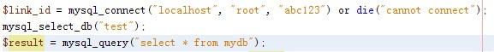
① test->mydb
Created for storing message left by customer and being deleted by administrator.
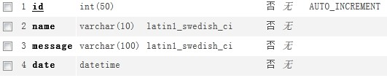

② test->study_group
Created for customer to be a user, in other word join the group.
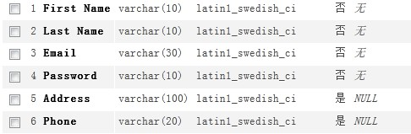

- Design for my project

The login page-------login.php
Description: the login page is only designed by the administrator. In other word, only administrator has access to modify the web, such as the delete the message left.
(Input Admin Name is admin, Password is admin .then click login)
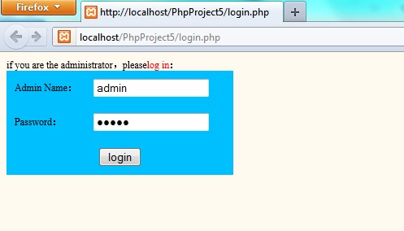
Figure 4.1 login page
(Then the page will jump out a Pop-up dialog box, click ”确定”. Then the page will jump to home page automatically.)
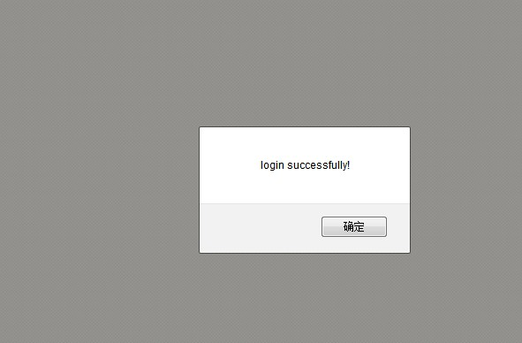

The home page-------home.php

Add a link to text
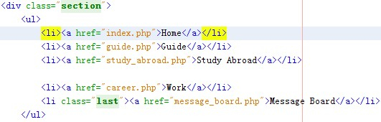

Add email
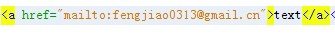

Add picture

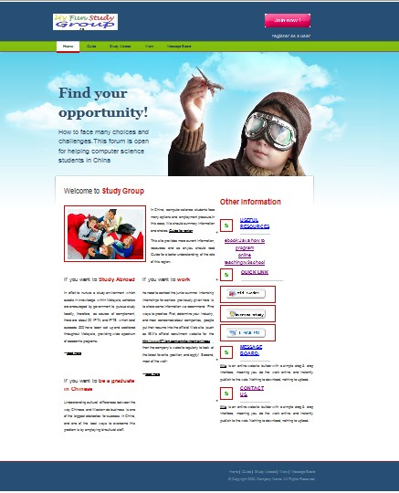
Function1
Function2
Function 5
Function 5
Figure 4.2 home page
Function implemented:
1) Register a user and the personal information is stored in database. (For management)
2) Menu bar shows other links to web page inside the website. When mouse entered, the background of the menu will change.
3) Insert picture and add word on the picture.
4) Content-left: display the short summary article and the link for the whole article.
5) Content-right: display the text link and picture link for useful resources.
6) Email to Administrator

7) Foot: display the picture link for hot website and text link for web page inside the website.
Figure 4.3 home page’s foot

Message board
You can turn to message board through clicking menu bar or content-right or foot.
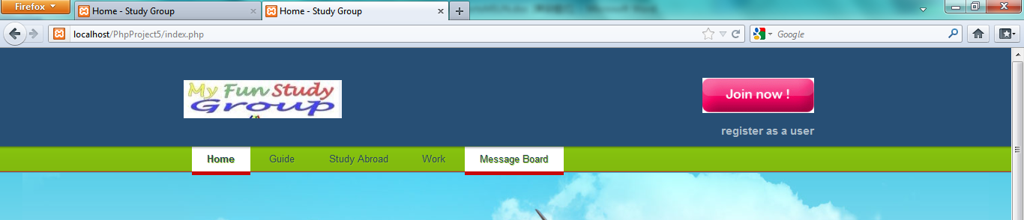
Click it
Figure 4.4 turn to message board
(You can add a message or delete a message.)
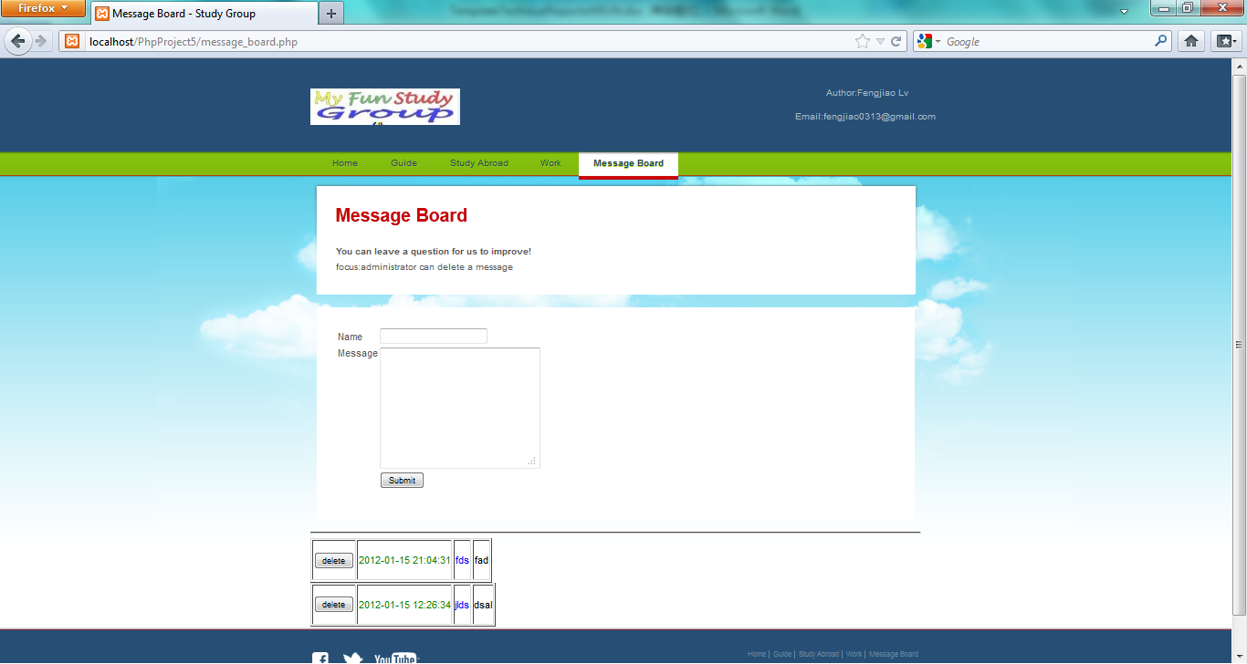
Figure 4.4 message board.

connect to datebase

creatr database

Other page
There exists some other page for display message.
(You can turn to this through the link)
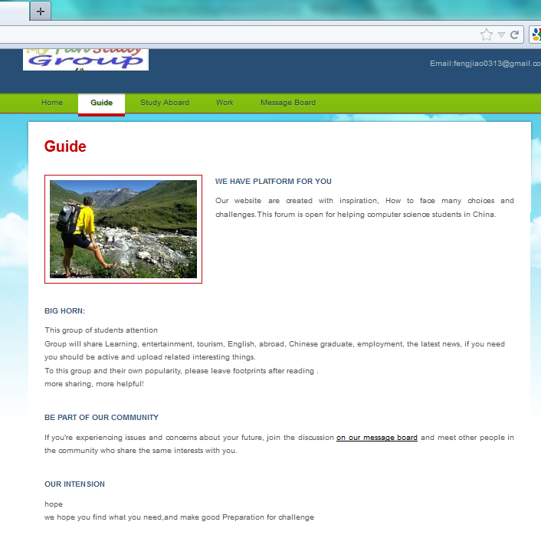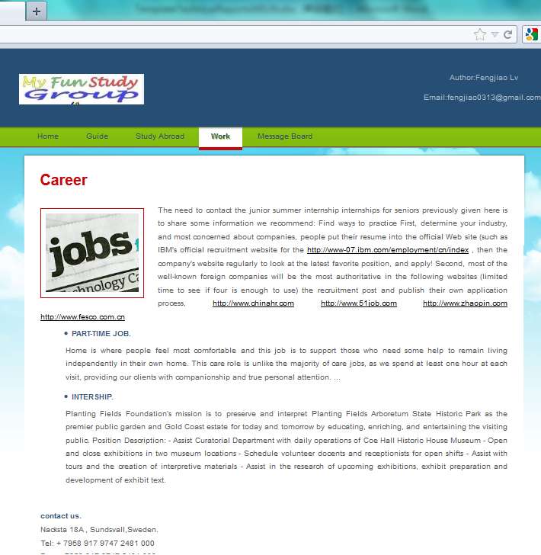
Figure 4.5 other page
- Results

the login page-------login.php
Input address: http://localhost/PhpProject5/login.php or run in net bean login.php.
(Input Admin Name is admin, Password is admin .then click login)
Figure 5.1 login page
(Then the page will jump out a Pop-up dialog box, click”确定”.Then the page will jump to home page automatically.)
Figure 5.2 pop-up window

the home page-------home.php
Function1
Function2
Function 5
Function 5
Figure 5.3 home page
Function implemented:
1) Register a user and the personal information is stored in database.(for management)
2) Menu bar shows other links to web page inside the website. when mouse entered ,the background of the menu will change.
3) Insert picture and add word on the picture.
4) Content-left: display the short summary article and the link for the whole article.
5) Content-right: display the text link and picture link for useful resources.
6) Email to Administrator

7) Foot: display the picture link for hot website and text link for web page inside the website.
Figure 5.4 home page’s foot

Message board
You can turn to message board through clicking menu bar or content-right or foot.
Click it
Figure 5.5 turn to message board
(You can add a message or delete a message.)
Figure 5.6 message board.

Other page
There exists some other page for display message.
(You can turn to this through the link)
Figure 5.7 other page
- Conclusions
Weakness:
1) Web text can be edited, this will be more convenient to modify.
2) If user can post articles, this will be more active for sharing and communication.
3) If the password input wrong, lack exception handling.
4) If only user can add messages or post articles, some things connecting to database should be done.
Programmers often make the mistake of rewriting code that already exists. When you know what application components you need or----on a smaller scale-----what functions you need, check what’s available before beginning development.
One of the strengths of the PHP as a language is its large built-in function library. Always check to see whether an existing function does what you are trying to do. Finding the one you want usually isn’t too hard. A good way to do this is to browse the manual by function group.
Today's network security is increasingly becoming an important issue, developing a verification code with the user login module can improve the site's safety, the verification code is randomly generated, which can be letters, numbers, or characters. It can be pictures. We should learn about several implementations of methods and techniques.

References
- Donghua University, ”Welcome to Donghua University Library”,
http://library.dhu.edu.cn/english/pages/index.aspx
Published 2007
- Luke Welling, PHP and MySQL Web Development. Third Edition.., 2000

Appendix A: Documentation of own developed program code
login.php
<?php session_start(); ?>
<!DOCTYPE html PUBLIC "-//W3C//DTD XHTML 1.0 Transitional//EN" "http://www.w3.org/TR/xhtml1/DTD/xhtml1-transitional.dtd">
<html xmlns="http://www.w3.org/1999/xhtml">
<head>
<meta http-equiv="Content-Type" content="text/html; charset=utf-8" />
<script type="text/javascript" language="javascript">
function checkLogin(){
var uname = document.getElementById('loginName').value;
var upass = document.getElementById('loginPass').value;
if(uname=="admin" ){
if(upass=="admin"){
alert("login successfully!");
window.location.href="index.php";
}
}
else{
alert('Error!please reput ');
}
}
</script>
</head>

<body style="font-size:12px;" bgcolor="#FFFAF0">
<form id="loginForm" action="" method="POST">
<div class="div">
if you are the administrator，please<font color="Red">log in</font>：
<table bgcolor="#00BFFF" cellspacing="0" cellpadding="10">
<tr><td>Admin Name：</td><td><input name="loginName" type="text" value="admin" id="loginName"/></td><td><span id="d1"></span></td></tr>
<tr><td>Password：</td><td><input name="loginPass" type="password" value="admin" id="loginPass"/></td><td><span id="d2"></span></td></tr>
<tr><td colspan="3" align="center"><input name="submit" type="button" onclick="checkLogin();" value="login" /></td></tr>
</table>
</div>
</form>

</body>
</html>

Index.php
<html>
<head>
<meta charset="UTF-8" />
<title>Home - Study Group</title>
<link rel="stylesheet" type="text/css" href="style.css" />
<!--[if IE 6]>
<link rel="stylesheet" type="text/css" href="ie6.css" />
<![endif]-->
<script type="text/javascript" src="/js/common.js"></script>
<script type="text/javascript">
var _gaq = _gaq || [];
_gaq.push(['_setAccount', 'UA-241068-1']);
_gaq.push(['_trackPageview']);
(function() {
var ga = document.createElement('script'); ga.type = 'text/javascript'; ga.async = true;
ga.src = ('https:' == document.location.protocol ? 'https://ssl' : 'http://www') + '.google-analytics.com/ga.js';
var s = document.getElementsByTagName('script')[0]; s.parentNode.insertBefore(ga, s);
})();
</script>
</head>
<body>
<div id="page">
<div id="header">
<div id="section">
<div><a href="index.php"><img src="images/logo1.jpg" alt="Logo" /></a></div>
<span id="login"><a href="http://localhost/PhpProject5/register.php" class="join"><img src="images/join.gif"></a>
<h3>register as a user</h3>
</span>
</div>
<ul>
<li class="current"><a href="index.php">Home</a></li>
<li><a href="guide.php">Guide</a></li>
<li><a href="study_abroad.php">Study Abroad</a></li>

<li><a href="career.php">Work</a></li>
<li><a href="message_board.php">Message Board</a></li>
</ul>

<div id="tagline">
<div>
<h4>Find your opportunity!</h4>
<p>How to face many choices and challenges.This forum is open for helping computer science students in China</p>
</div>
</div>
</div>
<div id="content">
<div id="home">
<div>
<div id="aside">
<div>
<h1>Welcome to <span class="last">Study Group</span></h1>
<a href="index.php"><img src="images/picture1.jpg" alt="Image" /></a>
<p>In China, computer science students face many options and employment pressure.In this case, We should summary information and choice. <a href="http://www.freewebsitetemplates.com/">Guide for region</a></p>
<p>This site provides more current information, resources and so on.you should read Guide for a better understanding of the role of this region.</p>
</div>
<ul>
<li>
<h2><a href="study_abroad.php">If you want to <span class="last">Study Abroad</span></a></h2>
<p>In effort to nurture a study environment which excels in knowledge within Malaysia, scholars are encouraged by government to pursue study locally, therefore, as source of complement, there are about 20 IPTA and IPTS which total exceeds 500 have been set up and scattered throughout Malaysia, providing wide spectrum of academic programs.</p>
<p>---<a href="study_abroad.php">read more</a></p>
</li>
<li>
<h2><a href="career.php">If you want to <span class="last">work</span></a></h2>
<p>he need to contact the junior summer internship internships for seniors previously given here is to share some information we recommend: Find ways to practice
First, determine your industry, and most concerned about companies, people put their resume into the official Web site (such as IBM's official recruitment website for the <a href="http://www-07.ibm.com/employment/cn/index. html"/>http://www-07.ibm.com/employment/cn/index</a> , then the company's website regularly to look at the latest favorite position, and apply!
Second, most of the well-
</p>
<p>---<a href="career.php">read more</a></p>
</li>
<li>
<h2><a href="index.php">If you want to <span class="last">be a graduate in Chinese</span></a></h2>
<p>Understanding cultural differences between the way Chinese and Western do business is one of the biggest obstacles for success in China, and one of the best ways to overcome this problem is by employing bi-cultural staff.</p>
</li>

</ul>
</div>
<div id="calulate">

<h3>Other information</h3>
<ul>
<li>

<table width="182" border="0" cellspacing="0" cellpadding="0">
<tr>
<td width="35" align="center" style="border-bottom: 0px solid #CCCCCC;">
<img src="images/nav_pic.jpg" width="22" height="22" /></td>
<td width="147" class="th_str_blue" style="border-bottom: 1px solid #CCCCCC;"><h2><a href="resources.php">useful resources</a></h2></td>

</tr>
<tr>
<td height="8" colspan="2" align="center"> </td>
</tr>
<tr>
<td height="45" colspan="2" align="center">
<a href="http://download.csdn.net/detail/uranusian/181021" target="_blank">
ebook:Java how to program</a></td>
</tr>
<td height="45" colspan="2" align="center">
<a href="http://www.w3school.com.cn/php/" target="_blank">
online teaching:w3school </a></td>
</tr>
</table>

</li>
<li>
<table width="182" border="0" cellspacing="0" cellpadding="0">
<tr>
<td width="35" align="center" style="border-bottom: 0px solid #CCCCCC;">
<img src="images/nav_pic.jpg" width="22" height="22" /></td>
<td width="147" class="th_str_blue" style="border-bottom: 1px solid #CCCCCC;"><h2><a href="index.php">quick link</a></h2></td>

</tr>
<tr>
<td height="8" colspan="2" align="center"> </td>
</tr>
<tr>
<td height="45" colspan="2" align="center">
<a href="http://www.miun.se/" target="_blank">
<img src="images/btn_miun.jpg" width="180" height="38" border="0" /></a></td>

</tr>

<tr>
<td height="45" colspan="2" align="center">
<a href="http://www.cscse.edu.cn/" target="_blank"></a><img src="images/btn_xinx.jpg" width="180" height="38" border="0" /></a></td>
</tr>

<tr>
<td height="45" colspan="2" align="center"><a href="mailto:fengjiao0313@gmail.cn"><img src="images/btn_catolog.jpg" width="180" height="38" border="0" /></a></td>
</tr>
</table>
</li>
<li>

<table width="182" border="0" cellspacing="0" cellpadding="0">
<tr>
<td width="35" align="center" style="border-bottom: 0px solid #CCCCCC;">
<img src="images/nav_pic.jpg" width="22" height="22" /></td>
<td width="147" class="th_str_blue" style="border-bottom: 1px solid #CCCCCC;"><h2><a href="message_board.html.">message board.</a></h2></td>

</tr>
</table>

<p><a rel="nofollow" name="xlnkS_wix_prv_tl_20" href="http://www.wix.com/thebesttemplates/wixeditor?utm_source=freewebsitetemplates&amp;utm_medium=link&amp;utm_term=preview&amp;utm_content=ma_fwt_preview2&amp;utm_campaign=ma_fwt&amp;experiment_id=ma_fwt_preview2">Wix</a> is an online website builder with a simple drag &amp; drop interface, meaning you do the work online and instantly publish to the web. Nothing to download, nothing to upload.</p>
</li>
<li>

<table width="182" border="0" cellspacing="0" cellpadding="0">
<tr>
<td width="35" align="center" style="border-bottom: 0px solid #CCCCCC;">
<img src="images/nav_pic.jpg" width="22" height="22" /></td>
<td width="147" class="th_str_blue" style="border-bottom: 1px solid #CCCCCC;"><h2><a href="index.php">contact us.</a></h2></td>

</tr>
</table>

<p><a rel="nofollow" name="xlnkS_wix_prv_tl_20" href="http://www.wix.com/thebesttemplates/wixeditor?utm_source=freewebsitetemplates&amp;utm_medium=link&amp;utm_term=preview&amp;utm_content=ma_fwt_preview2&amp;utm_campaign=ma_fwt&amp;experiment_id=ma_fwt_preview2">Wix</a> is an online website builder with a simple drag &amp; drop interface, meaning you do the work online and instantly publish to the web. Nothing to download, nothing to upload.</p>
</li>
</ul>
</div>
</div>
</div>
</div>
<div id="footer">
<div>
<div id="connect">
<a href="http://facebook.com" target="_blank"><img src="images/icon-facebook.gif" alt="Facebook" /></a>
<a href="http://twitter.com" target="_blank"><img src="images/icon-twitter.gif" alt="Twitter" /></a>
<a href="http://www.youtube.com" target="_blank"><img src="images/icon-youtube.gif" alt="Youtube" /></a>
</div>
<div class="section">
<ul>
<li><a href="index.php">Home</a></li>
<li><a href="guide.php">Guide</a></li>
<li><a href="study_abroad.php">Study Abroad</a></li>

<li><a href="career.php">Work</a></li>
<li class="last"><a href="message_board.php">Message Board</a></li>
</ul>
<p>&copy; Copyright 0000. Company Name. All Rights Reserved.</p>
</div>
</div>

</div>
</div>
</body>
</html>

